TASK – 5

**PROGRAMS DONE IN ANONYMOUS FUNCTION AND IIFE**

1. PRINT ODD NUMBER

A:

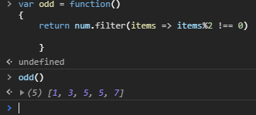

2). CONVERT ALL THE STRINGHS TO TITLE CAPS IN A STRING

A:

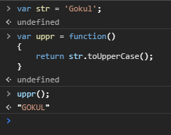

3). SUM OF ALL NUMBERS IN AN ARRAY

A:

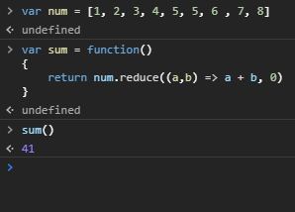

4).RETURN ALL THE PRIME NUMBERS IN AN ARRAY

A:

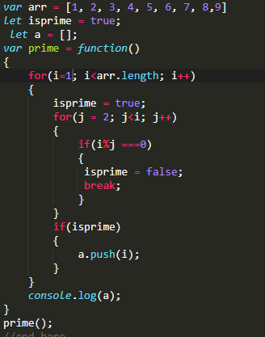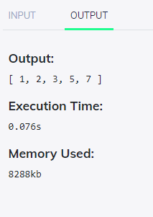

5) RETURN ALL THE PALINDROMES IN AN ARRAY

A: CODE

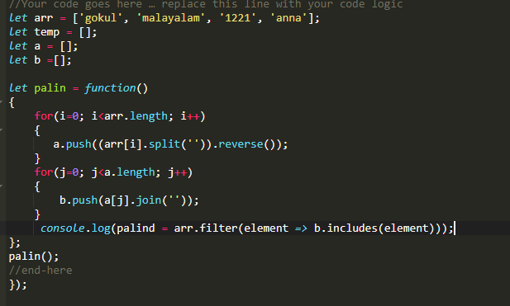

OUTPUT

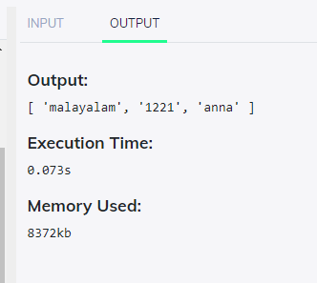

6). RETURN MEDIAN OF TWO SORTED ARRAYS OF SAME SIZE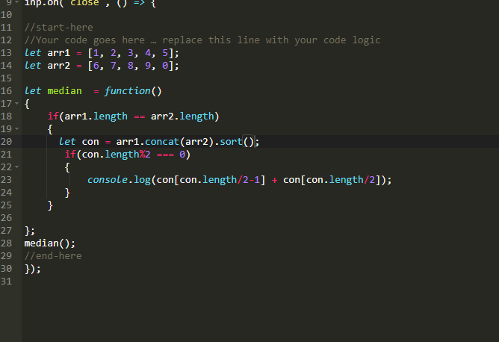

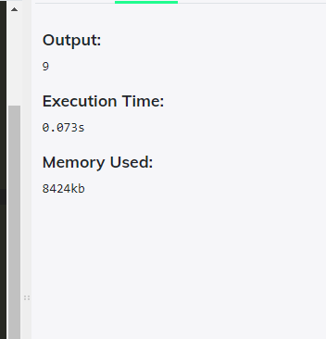

7). Remove duplicates from an array

A: CODE:

let arr = [1, 2, 3, 4, 5, 6, 6 , 7, 8, 9, 2, 7];

let temp = [];

( function(){

console.log(temp = [...new Set(arr)]);

})();

OUTPUT:

[ 1, 2, 3, 4, 5, 6, 7, 8, 9 ]

Execution Time:

0.074s

Memory Used:

8328kb

8). ROTATE AN ARRAY BY K TIMES AND RETURN THE ROTATED ARRAY

A:

